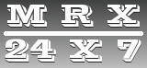

**LAUNDRY & TEXTILE CHEMICALS**

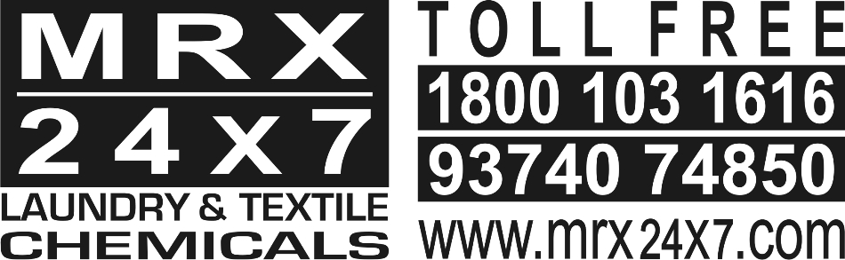

MRX 24x7 is first-of-its-kind initiative in chemicals industry. It is a vibrant cash and carry platform catering to all the requirements of Textile and Garment Processing industry. The concept is backed by rich experience spanning over decades and thorough understanding of the requirements and day-to-day challenges being confronted by small and medium sized players in the industry.

It is a unique platform offering a complete range of products and services from the most reputed manufacturers in the industry.MRX 24x7 is committed to highest standards of customer service and customer delight in each experience!

|  |  |
| --- | --- |
| Specialities | Commodities |
| Value Soft  Value Soft Plus  Premium Silicon  Maxsof RTU  Easywet  Cotionic Flakes  Clean R Plus  Desizer LT  Bio Strong  Deni Strong  Deni Sand  Deni Star  Deni Shine ABX  Deni Shine ABX Plus  Deni Wax | Potassium Permanganate  Peroxide Neutralizer  Sodium Metabisulphite  Pumic stone  Sodium Sulfide  Dye Fixing Agent  Soda Ash  Caustic Flakes  Hydrogen Peroxide  Acetic Acid  Bleaching Powder  Water Treatment chemicals  Perlite Powder  Optical Brightener |

**Our Services**

24 Hrs Services

Delivery Timing 7 am To 11 pm

Rs 5000 And Above Door Delivery

Boiler Maintenance

Machine Maintenance

Electrical Maintenance

Effluent Treatment Consultation

Technical Consultancy

Man Power Consultancy

Testing Services

Lab Equipment

Lab Consumables

Spares (Motors), Gears, Valves

Shop Address:

21, Anand Industrial Estate

Opp.Cozy Hotel Lane

Near Arvee Denim, Narol

Ahmedabad-382405 Gujarat, India

Contact Us (Toll-Free)

1800 103 1616

93 74 07 48 50

Website: [www.mrx24x7.com](http://www.mrx24x7.com)

Mail: info@mrx24x7.com